**Program 1**

10/05/2021

**Aim:** Program to draw Circle, Rectangle, Line in Applet.

**Algorithm:**

Step 1: Start

Step 2: Create a class called areaover.  
Step 3: Create 2 member functions to calculate the area of

rectangle and circle.  
Step 4: Perform the area finding operations inside the

functions.  
Step 5: create object of the class area  
Step 6: call the functions which is created using objects  
Step 7: print the values of area of each shape  
Step 8: Stop

**Source Code:**

import java.applet.Applet;

import java.awt.*;

public class shapes extends Applet{

public void paint(Graphics g){

g.drawLine(50,30, 300, 30);

g.setColor(Color.BLUE);

g.fillRect(50, 80, 200, 40);

g.setColor(Color.RED);

g.fillOval(50,150,100,100);

g.setColor(Color.CYAN);

int x1[]={40, 130, 200, 50};

int y1[]={310, 260, 310, 310};

int n1=4;

g.fillPolygon(x1, y1, n1);

}

}

**Output:**

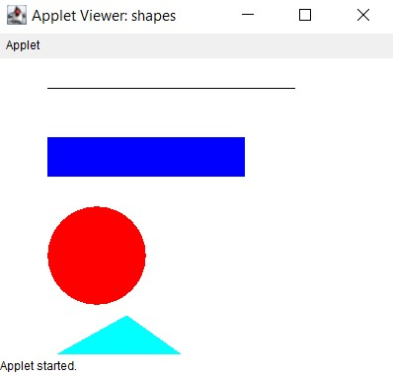

**Program 2**

10/05/2021

**Aim:** Program to draw Circle, Rectangle, Line in Applet.

**Algorithm:**

**Source Code:**

import java.awt.*;

import java.applet.*;

public class largest extends Applet

{

TextField Txt1,Txt2,Txt3;

public void init(){

Txt1 = new TextField(10);

Txt2 = new TextField(10);

Txt3 = new TextField(10);

add(Txt1);

add(Txt2);

add(Txt3);

Txt1.setText("num1");

Txt2.setText("num2");

Txt3.setText("num3");

}

public void paint(Graphics g){

int a, b, c,result;

String str;

g.drawString("Enter the numbers",10,50);

str=Txt1.getText();

a=Integer.parseInt(str);

str=Txt2.getText();

b=Integer.parseInt(str);

str=Txt3.getText();

c=Integer.parseInt(str);

if (a>b) {

if (a>c)

result=a;

else

result=c;

}

else{

if (b>c)

result=b;

else

result=c;

}

g.drawString("Largest number is "+result,10,70);

}

public boolean action(Event e, Object o){

repaint();

return true;

}

}

**Output:**

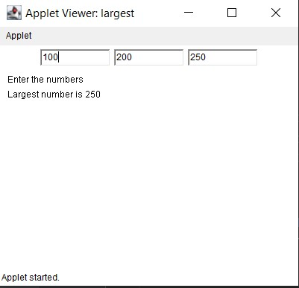

**Program 3**

10/05/2021

**Aim:** Find the percentage of marks obtained by a student in 5

subjects. Display a happy face if he secures above 50%

or a sad face if otherwise.

**Algorithm:**

**Source Code:**

import java.applet.*;

import java.awt.*;

import java.awt.event.*;

public class smile extends Applet implements ActionListener {

TextField t1,t2,t3,t4,t5,t6;

Button b;

Label l1,l2,l3,l4,l5,l6;

public void init(){

l1=new Label("mark1");

//l1.setBounds(100,100,200,20);

t1= new TextField(5);

//t1.setBounds(100,50,200,20);

l2=new Label("mark2");

//l2.setBounds(100,130,100,30);

t2= new TextField(5);

//t2.setBounds(100,80,100,20);

l3=new Label("mark3");

//l3.setBounds(100,160,100,20);

t3= new TextField(5);

//t3.setBounds(100,120,100,20);

l4=new Label("mark4");

//l4.setBounds(100,130,100,30);

t4= new TextField(5);

//t4.setBounds(100,80,100,20);

l5=new Label("mark5");

//l5.setBounds(100,130,100,30);

t5= new TextField(5);

//t5.setBounds(100,80,100,20);

l6=new Label("result");

//l6.setBounds(100,200,100,20);

t6=new TextField(5);

t1.setBounds(210,40,100,20);

t2.setBounds(210,80,100,20);

t3.setBounds(210,120,100,20);

t4.setBounds(210,80,100,20);

t5.setBounds(210,120,100,20);

t6.setBounds(210,140,100,20);

l1.setBounds(100,40,100,20);

l2.setBounds(100,80,100,20);

l3.setBounds(100,120,100,20);

l4.setBounds(100,140,100,20);

l5.setBounds(100,120,100,20);

l6.setBounds(100,140,100,20);

b=new Button("find");

b.setBounds(230,150,60,50);

//t4.setBounds(100,200,100,20);

add(l1);

add(t1);

add(l2);

add(t2);

add(l3);

add(t3);

add(l4);

add(t4);

add(l5);

add(t5);

add(b);

b.addActionListener(this);

add(l6);

add(t6);

}

public void actionPerformed(ActionEvent e){

int mark1=0;

int mark2=0;

int mark3=0;

int mark4=0;

int mark5=0;

int total=0;

mark1= Integer.parseInt(t1.getText());

mark2= Integer.parseInt(t2.getText());

mark3= Integer.parseInt(t3.getText());

mark4= Integer.parseInt(t2.getText());

mark5= Integer.parseInt(t3.getText());

if(e.getSource()==b){

total=(mark1+mark2+mark3+mark4+mark5)/5;

t6.setText(String.valueOf(total));

}

}

@Override

public void paint(Graphics g){

int mark1=0;

int mark2=0;

int mark3=0;

int mark4=0;

int mark5=0;

int total=0;

mark1= Integer.parseInt(t1.getText());

mark2= Integer.parseInt(t2.getText());

mark3= Integer.parseInt(t3.getText());

mark4= Integer.parseInt(t2.getText());

mark5= Integer.parseInt(t3.getText());

total=(mark1+mark2+mark3+mark4+mark5)/5;

g.setColor(Color.yellow);

g.fillOval(20,20,150,150); // For face

g.setColor(Color.black);

g.fillOval(50,60,15,25); // Left Eye

g.fillOval(120,60,15,25); // Right Eye

int x[] = {95,85,106,95};

int y[] = {85,104,104,85};

g.drawPolygon(x, y, 4); // Nose

g.fillPolygon(x, y, 4);

// g.drawLine(50,126,60,116); // Smile arc1

//g.drawLine(128,115,139,126); // Smile arc2

if(total > 50){

g.drawArc(55,95,78,50,0,-180); // Smile

}

else

{

g.drawArc(55,120,78,50,0,180); // Smile

}

}}

**Output:**

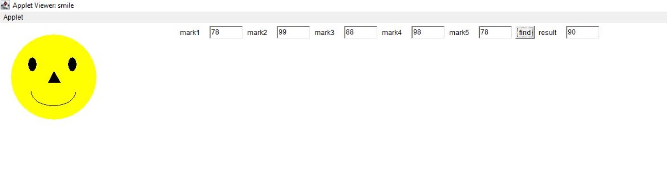

**Program 4**

10/05/2021

**Aim:** Using 2D graphics commands in an Applet, construct a

house. On mouse click event, change the color of the

door from blue to red.

**Algorithm:**

**Source Code:**

import java.awt.*;

import java.applet.*;

import java.awt.Graphics;

import java.awt.event.*;

public class MouseClick extends Applet implements MouseListener

{

int a,b;

public void init()

{

addMouseListener(this);

}

public void paint(Graphics gp)

{ int [] x = {170, 280, 300,150};

int [] y = {100, 100, 150, 150};

gp.setColor(Color.cyan);

gp.fillRect(150, 150, 150, 200); //House

gp.drawRect(200, 200, 50, 150); // Door

gp.setColor(Color.pink);

gp.fillRect(200,200,50,150);

gp.setColor(Color.gray);

gp.fillPolygon(x,y,4);

if(a>200 && a<300 && b>200 && b<300)

{

gp.setColor(Color.orange);

gp.fillRect(200, 200, 50, 150);

}

}

public void mouseClicked(MouseEvent e)

{

}

public void mouseEntered(MouseEvent e)

{

}

public void mouseExited(MouseEvent e) {

}

public void mousePressed(MouseEvent e)

{

a=e.getX();

b=e.getY();

repaint();

}

public void mouseReleased(MouseEvent e)

{

}

}

**Output:**

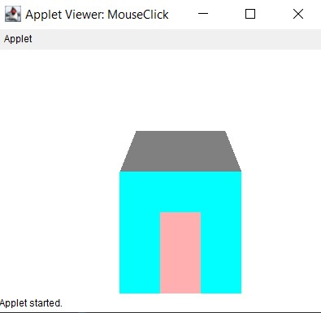

**Program 5**

10/05/2021

**Aim:** Implement a simple calculator using AWT

components.

**Algorithm:**

**Source Code:**

import java.awt.*;

import java.awt.event.*;

class calculator implements ActionListener {

Frame f = new Frame();

Label l1 = new Label("1st Integer");

Label l2 = new Label("2nd Integer");

Label l3 = new Label("Result");

TextField t1 = new TextField();

TextField t2 = new TextField();

TextField t3 = new TextField();

Button b1 = new Button("Add");

Button b2 = new Button("Sub");

Button b3 = new Button("Mul");

Button b4 = new Button("Div");

calculator() {

l1.setBounds(50, 100, 100, 20);

l2.setBounds(50, 150, 100, 20);

l3.setBounds(50, 200, 100, 20);

t1.setBounds(200, 100, 100, 20);

t2.setBounds(200, 150, 100, 20);

t3.setBounds(200, 200, 100, 20);

b1.setBounds(50, 250, 50, 20);

b2.setBounds(110, 250, 50, 20);

b3.setBounds(170, 250, 50, 20);

b4.setBounds(230, 250, 50, 20);

f.add(l1);

f.add(l2);

f.add(l3);

f.add(t1);

f.add(t2);

f.add(t3);

f.add(b1);

f.add(b2);

f.add(b3);

f.add(b4);

b1.addActionListener(this);

b2.addActionListener(this);

b3.addActionListener(this);

b4.addActionListener(this);

f.setLayout(null);

f.setVisible(true);

f.setSize(500, 500);

}

public void actionPerformed(ActionEvent e) {

int i = Integer.parseInt(t1.getText());

int j = Integer.parseInt(t2.getText());

if (e.getSource() == b1) {

t3.setText(String.valueOf(i + j));

}

if (e.getSource() == b2) {

t3.setText(String.valueOf(i - j));

}

if (e.getSource() == b3) {

t3.setText(String.valueOf(i * j));

}

if (e.getSource() == b4) {

t3.setText(String.valueOf(i / j));

}

}

public static void main(String[] args)

{

new calculator();

}

}

**Output:**

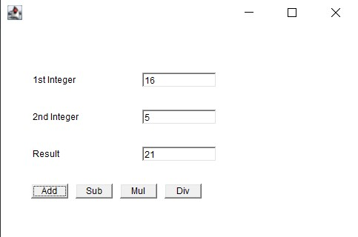

**Program 6**

10/05/2021

**Aim:** Develop a program that has a Choice component which

contains the names of shapes such as rectangle,

triangle, square and circle. Draw the corresponding

shapes for given parameters as per user’s choice.

**Algorithm:**

**Source Code:**

import java.applet.Applet;

import java.awt.*;

import java.awt.Graphics;

import java.awt.event.*;

public class Shape extends Applet implements ItemListener

{

Choice choice;

int rectX;

int rectY;

int rectWidth ;

int rectHeight;

String shape;

int Selection;

public void init()

{

choice = new Choice();

choice.addItem("Choose the shape");

choice.addItem("Rectangle");

choice.addItem("Triangle");

choice.addItem("Square");

choice.addItem("Circle");

add(choice);

choice.addItemListener(this);

}

public void itemStateChanged (ItemEvent e)

{

// set new selection index

Selection = choice.getSelectedIndex();

repaint();

}

public void paint(Graphics g)

{

super.paint(g);

if (Selection == 1)

{

g.setColor(Color.BLUE);

g.fillRect(70,70,200,130);

g.drawRect(70,70,200,130);

}

if (Selection == 2)

{

int xArray[] ={110,180,30,110};

int yArray[] ={30,100,100,30};

g.setColor(Color.green);

g.fillPolygon(xArray,yArray,4);

}

if (Selection == 3)

{

g.setColor(Color.BLACK);

g.fillRect(150,150,100,100);

g.drawRect(150,150,100,100);

}

if (Selection ==4)

{

g.setColor(Color.red);

g.fillOval(130,100,190,190);

g.drawOval(130,100,190,190);

}

}

}

**Output:**

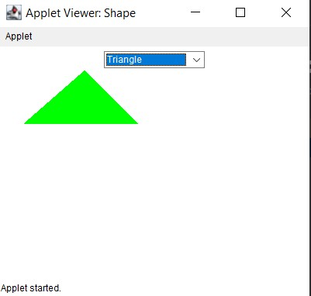

**Program 7**

10/05/2021

**Aim:** Develop a program to handle all mouse events and

window events.

**Algorithm:**

**Source Code:**

import java.awt.*;

import java.awt.event.MouseEvent;

import java.awt.event.MouseListener;

import java.awt.event.WindowEvent;

import java.awt.event.WindowListener;

public class MouseWindowEvent extends Frame implements MouseListener{

Label l;

MouseWindowEvent(){

addMouseListener(this);

l=new Label();

l.setBounds(20,50,100,20);

add(l);

setSize(300,300);

setLayout(null);

setVisible(true);

}

public void mouseClicked(MouseEvent e) {

l.setText("Mouse Clicked");

}

public void mouseEntered(MouseEvent e) {

l.setText("Mouse Entered");

}

public void mouseExited(MouseEvent e) {

l.setText("Mouse Exited");

}

public void mousePressed(MouseEvent e) {

l.setText("Mouse Pressed");

}

public void mouseReleased(MouseEvent e) {

l.setText("Mouse Released");

}

public static void main(String[] args) {

new MouseListenerExample();

new WindowExample();

}

}

class WindowExample1 extends Frame implements WindowListener{

WindowExample1(){

addWindowListener(this);

setSize(400,400);

setLayout(null);

setVisible(true);

}

public void windowActivated(WindowEvent arg0) {

System.out.println("activated");

}

public void windowClosed(WindowEvent arg0) {

System.out.println("closed");

}

public void windowClosing(WindowEvent arg0) {

System.out.println("closing");

dispose();

}

public void windowDeactivated(WindowEvent arg0) {

System.out.println("deactivated");

}

public void windowDeiconified(WindowEvent arg0) {

System.out.println("deiconified");

}

public void windowIconified(WindowEvent arg0) {

System.out.println("iconified");

}

public void windowOpened(WindowEvent arg0) {

System.out.println("opened");

}

}

**Output:**

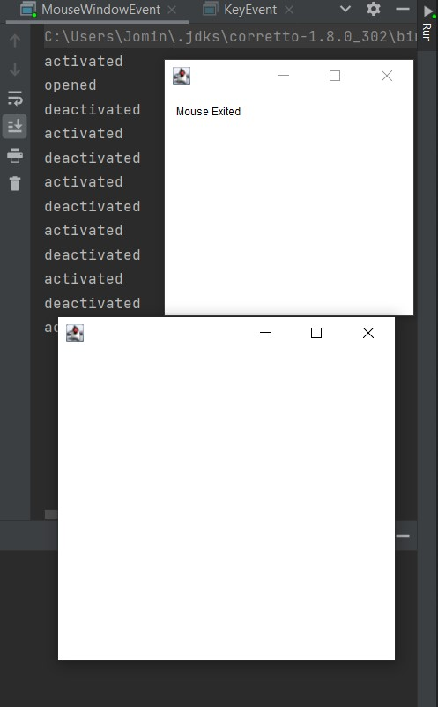

**Program 8**

10/05/2021

**Aim:** Develop a program to handle Key events.

**Algorithm:**

**Source Code:**

import java.awt.*;

import java.awt.event.*;

import java.awt.event.KeyEvent;

public class KeyEvents extends Frame implements

KeyListener{

Label l;

TextArea area;

KeyEvents(){

l=new Label();

l.setBounds(20,50,100,20);

area=new TextArea();

area.setBounds(20,80,300, 300);

area.addKeyListener(this);

add(l);add(area);

setSize(400,400);

setLayout(null);

setVisible(true);

}

public void keyPressed(KeyEvent e) {

l.setText("Key Pressed");

}

public void keyReleased(KeyEvent e) {

l.setText("Key Released");

}

public void keyTyped(KeyEvent e) {

l.setText("Key Typed");

}

public static void main(String[] args) {

new KeyListenerExample();

}

}

**Output:**

